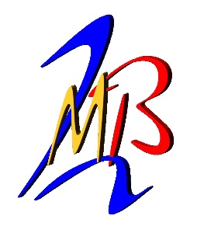
BT Personnel Pty Ltd
278 Hammond Avenue
Wagga Wagga NSW 2650
Ph: 02 6923 7300
Fax: 02 6971 0484
ABN: 39 158 408 854

VEHICLE PAINTER/SPRAYPAINTER (CERTIFICATE 3 - HEAVY VEHICLES)

BT Personnel Pty Ltd are seeking to fill the above positions on behalf of Byrne Trailers Pty Ltd.

Byrne Trailers is a leading manufacturer of Heavy Vehicle Transport Equipment with its Head Office based in Wagga Wagga NSW and a division in Toowoomba QLD.

We are looking for:
We are seeking Vehicle Painter/ Spray Painter with a Certificate 3 Qualification, to join our team in our Wagga Factory. Reporting to the Factory Manager, you will be required to work in a fast paced factory environment whilst meeting strict deadlines.

You will need:
~ Certificate 3 in Vehicle Painting Qualification or equivalent experience
~ Demonstrated knowledge in the use and care of technical equipment
~ Experience in a busy production environment requiring planning, organisation and prioritising your work
~ Awareness of occupational hazards and application of appropriate control measures
~ Ability to work in a team or independently, unsupervised and with a professional attitude
~ Quality focused with a good eye for detail

What we offer:
~ Full Time position
~ A 5 Day roster with overtime available
~ Competitive pay ($65,000 to $69,160 depending on skills and experience)
~ Great working terms and conditions
~ On site commercial cafeteria
~ Uniform, PPE, Training and immediate start
~ Relocation assistance can be provided

Next Steps:
If this sounds like the position for you, please submit your resume to administration@byrnetrailers.com.au

